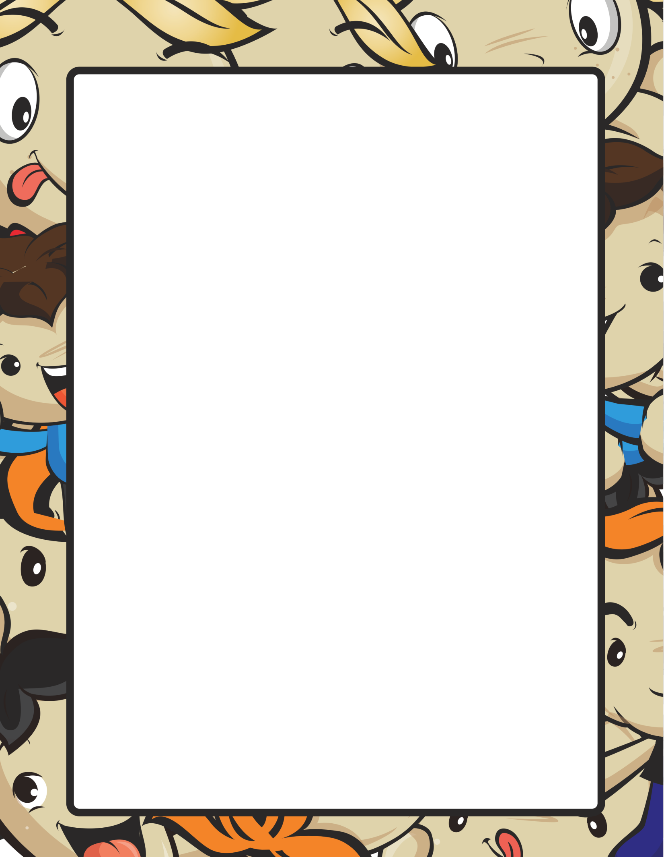

Name __________________________ Date ________________________

**MY BOOK REPORT**

*Title of the Book*

____________________________________

*Author’s Name*

___________________________________

My Favorite character was

_____________________________________________________________________________________

_____________________________________________________________________________________

_______________________________

The most appealing event in the story is

_____________________________________________________________________________________

_____________________________________________________________________________________

________________________________

Write 2 sentences describing the book and how you wish the story ended

_____________________________________________________________________________________

_____________________________________________________________________________________

_________________________________